

**Machine Learning – Summer 2020**

**Term Project – Project Proposal**

**Guitar Chord Estimater**

**MECH74100**

**Electronic Systems Engineering**

**School of Engineering Information and Technology**

**Conestoga College**

**Date: July 7th, 2020**

**Prepared By: Robert Boettcher – 6695217**

**Bradley Williams 7511405**

**Prepared for**

**Ali Tehrani**

Introduction

Guitar is a six string fretted, musical instrument. The player typically plays it by using their left hand fingers on the the fret board and strumming them with their right hand. This allows a variation of tones to be played called notes. Sheet music for playing songs on guitar are called tablatures, an example of this is shown in figure 1. This document indicates what note is being played on which string and fret.

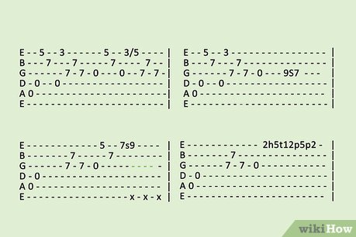

Most commonly, guitar music is played using a variety of patterns called chords. These cords have distinct shapes where they are played specially with a certain fingers on the fret-board. As seen bellow in figure 2 the chord diagram indicates were the fingers (1, index, 2 middle, 3 ring) are placed on the f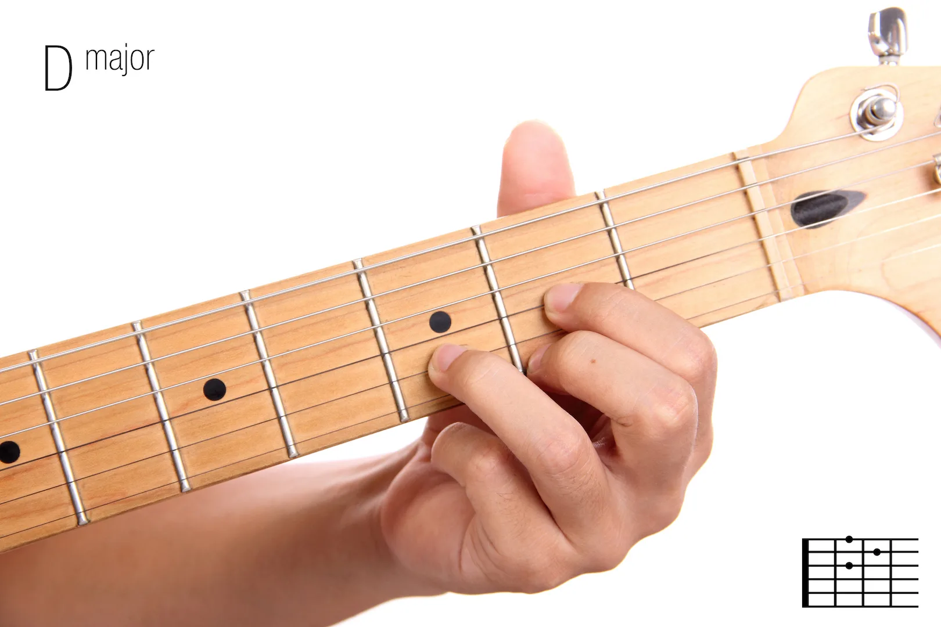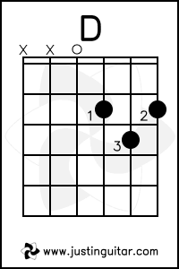ret board.

Purpose

It is somewhat controversal to say, but most music is not really unique in that basically all tablitures base the sequencing of notes off chord shapes. Simply put, a section of tabltiure is often based around the shape of a chord. This is not to say that a song can’t be played with only a single finger, it makes it much harder to learn, with really no advantage of following a chord shape. The goal of this project is take a tabliture that does not include chord shapes for each sections, and predict what the optimal chord shape would be.

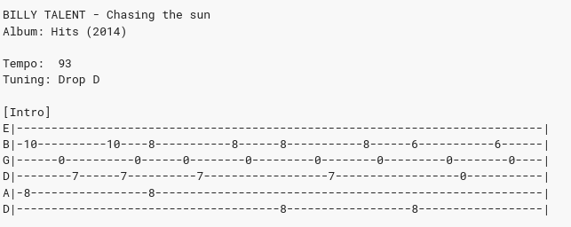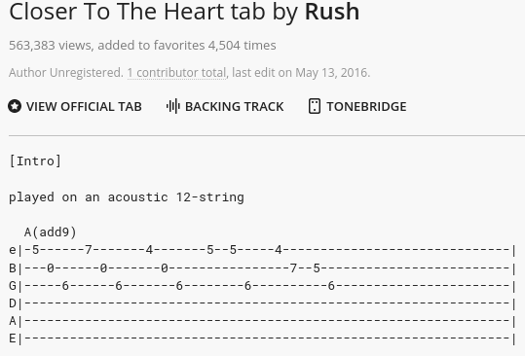

Given the above tabs, you can see just above the second figure a (A (add9)) This is the chord shape the fingers are placed in for this seqeunce. The top figure does not give such information. This makes it much harder to learn and practice that song as you need to figure out the optimal chord shape.

Solution

The solution to this problem will be solved using a verity of machine learning algorythms. Bascially the program will examin a section of a tab, and make a comparission to pre-determined chord shapes. This is technically be a supervised task as I would consider myself an intermedate level guitar player and can generally guess what the correct chord shape will be.